

CDS 3543
Data Visualization for Decision Making

Analyzing Student Habits and Their Impact on Academic Performance

Submitted By:
Mariam Almessabi | H00492656
Asma Alkarbi | H00492811
Hamdah Alkindi | H00492795

Submitted To:
Dr. Mohd Salihan Ab Rahman

Table of Contents
1. Introduction 2
2. Dataset Description 2
3. Features Description 3
4. Data Loading & Inspection 4
5. Data Preprocessing 7
6. Visualizations 10
6.1. Line Chart 10
6.2. Bar Chart 11
6.3. Heatmap 12
6.4. Scatter Plot 14
6.5. Histogram 15
6.6. Box Plot 16
6.7. Correlation Heatmap 17
7. Dashboard 18
8. Accessibility 20
9. Conclusion 20
10. References 21

Introduction
This study is about analyzing student behaviors and lifestyle choices that play a role into their academic performance and success. The dataset used in this project was acquired from Kaggle and aids in exploring what features make a critical impact on academic performance. Some of these features include digital habits, mind and body practices, personal and familial patterns, and academic behaviors.
The main objective of this project is to transform raw data into information through a process of exploring, cleaning, and visualizing the data. Exploration will include viewing the dataset in general, finding the statistical summary, and checking unique values. Then, preprocessing will include handling null and irregular values by means of dropping and imputing. Afterwards, six visual charts will be produced, and the most relevant ones will be used in a dashboard.
This data processing pipeline will lead to useful visuals which stakeholders can use to derive decisions from data and take proactive measures to enhance academic performance, tackle bad habits, and promote a healthier lifestyle for students to pursue.

Dataset Description
The dataset used for this project comes from Kaggle and is about analyzing how the habits and lifestyles of students impact their performance academically. The dataset contains over 1000 observations and includes 16 features with 1 target variable. Features include demographic information such as age, gender, and employment, digital habits such as number of hours per social media and Netflix, lifestyle patterns like diet quality, sleep hours, and exercise frequency, a mental health score, and the target variable exam score. These features combined provide a deeper insight into how certain patterns affect grades from a data perspective. Through this dataset, visualization and machine learning studies can be conducted to find what features affect student grades and view correlations and relationships of features with the target exam score (Nath, 2025).

Features Description
Feature name | Type | Description
student_id | Identifier | An id unique to each student
age | Integer | Age of the student
gender | Categorical | Gender of the student
study_hours_per_day | Float | Amount of hours spent studying per day
social_media_hours | Float | Amount of hours spent on social media per day
netflix_hours | Float | Amount of hours spent on netflix per day
part_time_job | Boolean | Whether a student is employed part time or not
attendance_percentage | Float | Percentage of student’s attendance in class
sleep_hours | Float | Average sleep hours per day
diet_quality | Categorical | Quality of the student’s diet
exercise_frequency | Integer | Amount of times a student exersices per week
parental_education | Categorical | The highest level of education reached by student’s parent
internet_quality | Categorical | Quality of student’s internet
mental_health_rating | Integer | A score between 1 and 10 where 1 represents a bad mental state while 10 means the student is in the best mental state
extracurricular_participation | Boolean | Whether a student is partaking in any extracurricular activities or not
exam_score | Target | How much a student scored on their exam out of 100

Data Loading & Inspection
df = pd.read_csv('student_habits_performance.csv')
df.head()

Showing the initial appearance of the dataset.
# basic details
df.info()
<class 'pandas.DataFrame'>
RangeIndex: 1000 entries, 0 to 999
Data columns (total 16 columns):
# Column Non-Null Count Dtype
--- ------ -------------- -----
0 student_id 1000 non-null str
1 age 1000 non-null int64
2 gender 1000 non-null str
3 study_hours_per_day 1000 non-null float64
4 social_media_hours 1000 non-null float64
5 netflix_hours 1000 non-null float64
6 part_time_job 1000 non-null str
7 attendance_percentage 1000 non-null float64
8 sleep_hours 1000 non-null float64
9 diet_quality 1000 non-null str
10 exercise_frequency 1000 non-null int64
11 parental_education_level 909 non-null str
12 internet_quality 1000 non-null str
13 mental_health_rating 1000 non-null int64
14 extracurricular_participation 1000 non-null str
15 exam_score 1000 non-null float64
dtypes: float64(6), int64(3), str(7)
memory usage: 125.1 KB

The columns have 3 data types which are float, integer, and string. Parental_education_level has null values.
# dataset shape
print(f"Dataset shape: {df.shape}")
Dataset shape: (1000, 16)

There are a total of 16 features and 1000 observations in the dataset initially.
# statistics summary
df.describe(include='all')
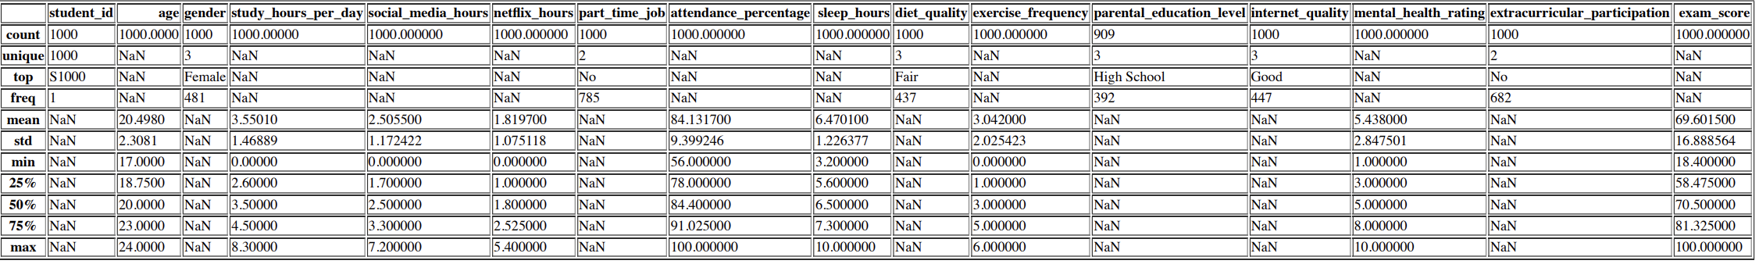

The statistical summary uncovers findings which include:
- The youngest student here is 17, the oldest is 24, and the average age is around 20. This means the dataset revolves around college students.
- The average number of study hours is around 3 per day, which is slightly lower than what’s needed to succeed academically.
- Averages of social media and Netflix are around 2 hours, which is a bit excessive considering the average college student workload. This time could be invested into more studying to achieve better scores.
- The average attendance is around 84 meaning students are mostly present and miss out on less information needed for exams.
- Top students in the 75% percentile have healthy sleep hours at around 7.3 which greatly helps them build better bodies and minds.
- The lowest exercise frequency observed is 0 which could suggest putting more effort in promoting exercise amongst students.
- The average mental health rating being 5 is concerning as mental health plays a critical role in academic success. The university should push for more initiatives involving mental health promotion.
- The variance between the lowest versus highest exam score is quiet big, with the minimum score achieved being 18 while the highest performers achieved 100. The average score is also 69 which isn’t ideal and the university should create strategies to increase average scores.

# unique values for categorical columns
for col in df.select_dtypes(include=['object', 'string']):
print(col, df[col].unique())
student_id <StringArray>
['S1000', 'S1001', 'S1002', 'S1003', 'S1004', 'S1005', 'S1006', 'S1007',
'S1008', 'S1009',
...
'S1990', 'S1991', 'S1992', 'S1993', 'S1994', 'S1995', 'S1996', 'S1997',
'S1998', 'S1999']
Length: 1000, dtype: str
gender <StringArray>
['Female', 'Male', 'Other']
Length: 3, dtype: str
part_time_job <StringArray>
['No', 'Yes']
Length: 2, dtype: str
diet_quality <StringArray>
['Fair', 'Good', 'Poor']
Length: 3, dtype: str
parental_education_level <StringArray>
['Master', 'High School', 'Bachelor', nan]
Length: 4, dtype: str
internet_quality <StringArray>
['Average', 'Poor', 'Good']
Length: 3, dtype: str
extracurricular_participation <StringArray>
['Yes', 'No']
Length: 2, dtype: str

Upon investigating unique values, we found a problem where there are 3 genders. This is wrong because there are only 2 genders and this’ll be handled accordingly. The unique value code also confirms the existence of null values in parental_education where they appear as a 4th category “NaN”.

# check for duplicates
df.duplicated().sum()
np.int64(0)

This dataset is free from repeated rows.

Data Preprocessing
# drop student_id column
df = df.drop(columns=['student_id'])

Dropped student_id as it serves no purpose in the study and is merely an identifier.

# rename columns
df = df.rename(columns={'study_hours_per_day': 'study_hours', 'extracurricular_participation': 'extra_acts', 'parental_education_level': 'parent_education', 'attendance_percentage': 'attendance', 'mental_health_score': 'mental_health'})
df.columns
Index(['age', 'gender', 'study_hours', 'social_media_hours', 'netflix_hours',
'part_time_job', 'attendance', 'sleep_hours', 'diet_quality',
'exercise_frequency', 'parent_education', 'internet_quality',
'mental_health_rating', 'extra_acts', 'exam_score'],
dtype='str')

Renamed several lengthy column names for clarity and simplicity

# encode gender, part_time_job, diet_quality, parent_education, internet_quality, extra_acts
df['gender'] = df['gender'].map({'Male': 0, 'Female': 1})
df['part_time_job'] = df['part_time_job'].map({'No': 0, 'Yes': 1})
df['diet_quality'] = df['diet_quality'].map({'Poor': 0, 'Fair': 1, 'Good': 2})
education_mapping = {'High School': 0, 'Bachelor': 1, 'Master': 2}
df['parent_education'] = df['parent_education'].map(education_mapping)
df['internet_quality'] = df['internet_quality'].map({'Poor': 0, 'Average': 1, 'Good': 2})
df['extra_acts'] = df['extra_acts'].map({'No': 0, 'Yes': 1})
df.head()
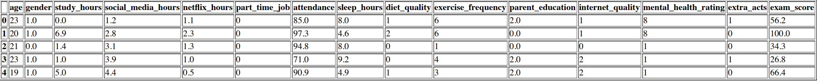

Encoded categorical variables to display if there are any nulls not previously caught

# check for null values again
df.isnull().sum()
age 0
gender 42
study_hours 0
social_media_hours 0
netflix_hours 0
part_time_job 0
attendance 0
sleep_hours 0
diet_quality 0
exercise_frequency 0
parent_education 91
internet_quality 0
mental_health_rating 0
extra_acts 0
exam_score 0
dtype: int64

Because only male and female were encoded, the “Other” category became null

# impute null values in parental_education with the most frequent value
most_frequent_value = df['parent_education'].mode()[0]
df['parent_education'] = df['parent_education'].fillna(most_frequent_value)

Since there were 91 nulls in parental_education, we wanted to maintain as many records as we can. So, we made the decision to impute nulls here with its most common value.

# drop null values in gender
df = df[df['gender'].notnull()]

Since there were only 42 null values in gender, we made the decision to drop them as they won’t affect the analysis and we were left at the end with a sizeable 958 rows which is sufficient.

# check nulls again
df.isnull().sum()
age 0
gender 0
study_hours 0
social_media_hours 0
netflix_hours 0
part_time_job 0
attendance 0
sleep_hours 0
diet_quality 0
exercise_frequency 0
parent_education 0
internet_quality 0
mental_health_rating 0
extra_acts 0
exam_score 0
dtype: int64

df.info()
<class 'pandas.DataFrame'>
Index: 958 entries, 0 to 999
Data columns (total 15 columns):
# Column Non-Null Count Dtype
--- ------ -------------- -----
0 age 958 non-null int64
1 gender 958 non-null float64
2 study_hours 958 non-null float64
3 social_media_hours 958 non-null float64
4 netflix_hours 958 non-null float64
5 part_time_job 958 non-null int64
6 attendance 958 non-null float64
7 sleep_hours 958 non-null float64
8 diet_quality 958 non-null int64
9 exercise_frequency 958 non-null int64
10 parent_education 958 non-null float64
11 internet_quality 958 non-null int64
12 mental_health_rating 958 non-null int64
13 extra_acts 958 non-null int64
14 exam_score 958 non-null float64
dtypes: float64(8), int64(7)
memory usage: 119.8 KB

The dataset is now free from nulls, has a unified numerical data type, and is fully clean and ready for visual analysis and dashboard creation.

Visualizations

Line Chart
# line chart for study_hours vs exam_score sorted by study_hours
plt.figure(figsize=(10, 6))
sns.lineplot(x='study_hours', y='exam_score', data=df.sort_values('study_hours'), errorbar=None)
plt.title('Study Hours vs Exam Score')
plt.xlabel('Study Hours per Day')
plt.ylabel('Exam Score')
plt.show()

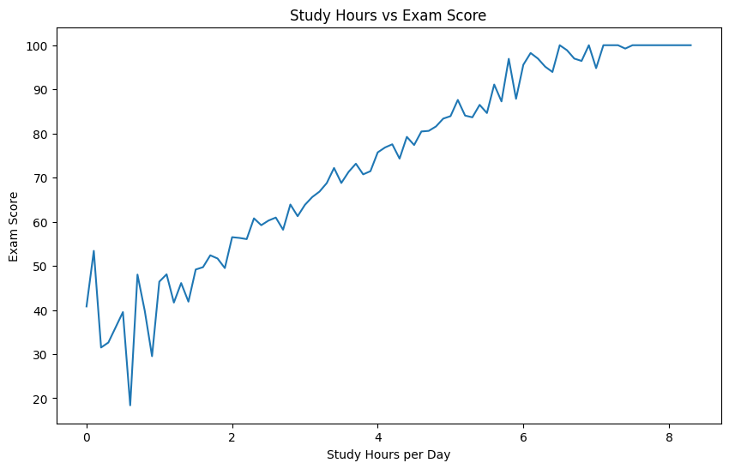
Figure 1: A line chart showing the relationship between study hours and exam score
This line chart demonstrates the relationship between study hours per day and exam scores. There’s a clear positive relationship going upward. As study hours increase, so do scores. The lowest scores are present at the least number of hours per day, with these students spending less than 2 hours studying. The line stabilizes after 7+ hours of studying, indicating that putting 7 or more hours per day to studying will almost guarantee high marks. This chart emphasizes the importance of student effort in getting higher marks.

Bar Chart
# average exam score by social media hours binned into 0-2, 2-4, 4-6, 6+ hours
df['social_media_hours_bin'] = pd.cut(df['social_media_hours'], bins=[-1, 2, 4, 6, np.inf], labels=['0-2', '2-4', '4-6', '6+'])
avg_scores = df.groupby('social_media_hours_bin')['exam_score'].mean().reset_index()
plt.figure(figsize=(10, 6))
sns.barplot(x='social_media_hours_bin', y='exam_score', data=avg_scores)
plt.title('Average Exam Score by Social Media Hours')
plt.xlabel('Social Media Hours per Day')
plt.ylabel('Average Exam Score')
plt.show()

# drop social_media_hours_bin
df = df.drop(columns=['social_media_hours_bin'])

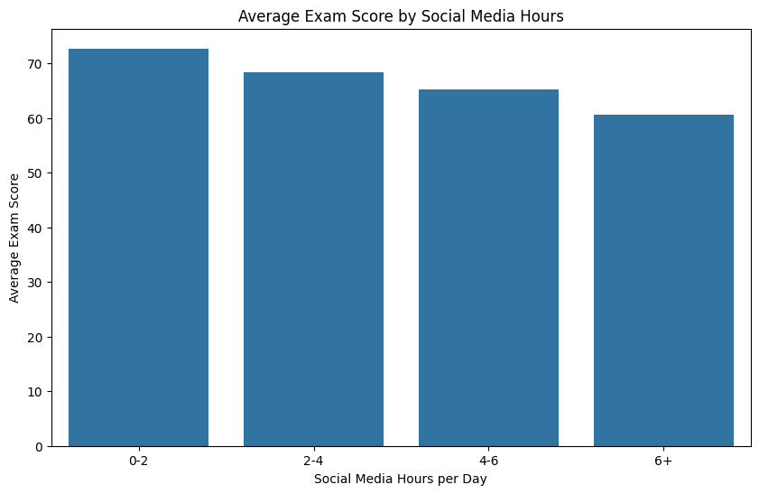
Figure 2: a bar chart showing social media hours binned per bar by avg exam score
The following bar chart demonstrates different ranges of time spent on social media against exam scores. The bar lengths decrease, meaning exam scores also decrease as hours increase. The group with the highest scores is present in the 0 to 2 hour range. People with the lowest scores tend to spend a lengthy time on social media, reaching and exceeding 6 hours. Spending too much time on social media can negatively affect student performance.

Heatmap
# heatmap of mental_health_rating vs exam_score ranges
df['exam_score_range'] = pd.cut(df['exam_score'], bins=[0, 60, 70, 80, 90, 100], labels=['0-60', '60-70', '70-80', '80-90', '90-100'])
heatmap_data = df.groupby(['mental_health_rating', 'exam_score_range']).size().unstack(fill_value=0)
plt.figure(figsize=(10, 6))
sns.heatmap(heatmap_data, annot=True, fmt='d', cmap='YlGnBu')
plt.title('Heatmap of Mental Health Rating vs Exam Score Ranges')
plt.xlabel('Exam Score Range')
plt.ylabel('Mental Health Rating')
plt.show()

# drop exam_score_range
df = df.drop(columns=['exam_score_range'])

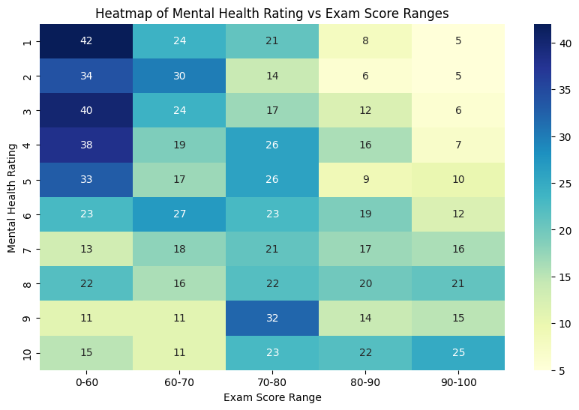
Figure 3: a heatmap showing the number of students per mental health rating by exam score range
This heatmap shows the count of students in each mental health score and how their achieved exam scores. Alarmingly, the densest spot in the heatmap lies where the mental score is 1 and scores are between 0 and 60 which is 42 students. This suggests that students are struggling mentally and need assistance as it affects their grades. The “happiest” 25 students have achieved marks with 90 and above and have a perfect 10 score in mental health.

Scatter Plot
# scatter plot of sleep_hours vs exam_score
plt.figure(figsize=(10, 6))
sns.scatterplot(x='sleep_hours', y='exam_score', data=df)
plt.title('Sleep Hours vs Exam Score')
plt.xlabel('Sleep Hours per Day')
plt.ylabel('Exam Score')
plt.show()

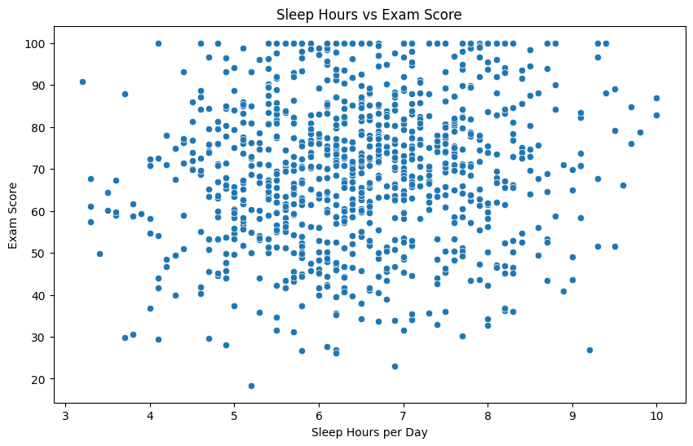
Figure 4: a scatter plot showing the correlation between sleep hours per day and exam scores
The scatter plot demonstrates a weak positive- no correlation between sleep duration and exam performance. It’s difficult to pinpoint the exact range of sleep hours where students tend to perform better as results show wide variations, which indicates that sleep does not determine their results. Other factors likely play a bigger role.

Histogram
# exam score distribution
plt.figure(figsize=(10, 6))
sns.histplot(df['exam_score'], bins=20, kde=True)
plt.title('Distribution of Exam Scores')
plt.xlabel('Exam Score')
plt.ylabel('Frequency')
plt.show()

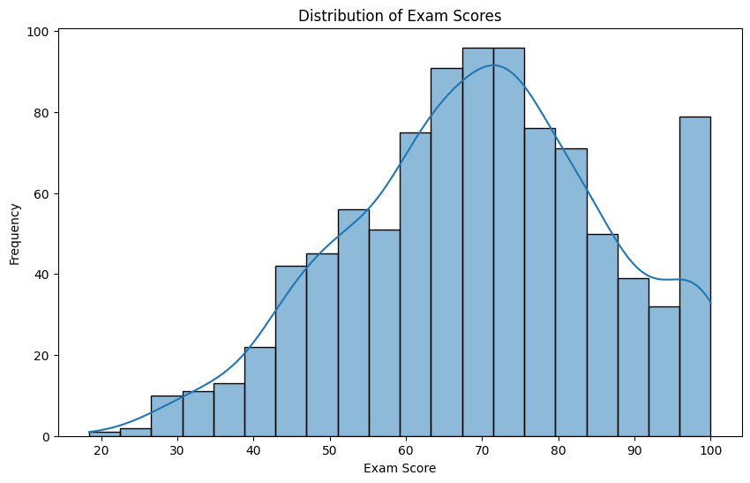
Figure 5: A histogram showing exam score distribution
The histogram shows that exam scores are roughly normally distributed, with most students scoring between 60 and 80. The peak is around the 70s, indicating this is the most common score range. The data shows slight variation because there are fewer students who receive extremely low or extremely high scores. There are also students who have scored above 90 and this is apparent in the histogram. There are barely any students who scored below 45.

Box Plot
# exam score by attendance level, attendance binned into 3 quantiles
df['attendance_group'] = pd.qcut(df['attendance'], q=3)

plt.figure(figsize=(10,6))
sns.boxplot(x='attendance_group', y='exam_score', data=df, palette=["#6baed6", "#9ecae1", "#c6dbef"])

plt.title('Exam Score by Attendance Level')
plt.xlabel('Attendance Level')
plt.ylabel('Exam Score')
plt.show()

# drop attendance_group column
df = df.drop(columns=['attendance_group'])

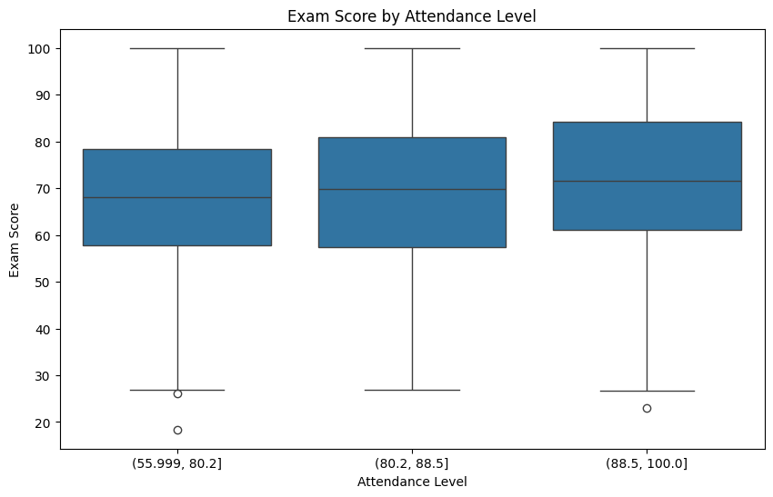
Figure 6: Three box plots, each showing statistical properties of exam score by attendance
The boxplot shows that students with higher attendance tend to have higher exam scores. The median score increases from the low attendance group to the high attendance group. The two groups show some overlap, but higher attendance typically leads to improved academic results.

Correlation Heatmap
# correlation heatmap for everything
plt.figure(figsize=(12, 10))
sns.heatmap(df.corr(), annot=True, cmap='coolwarm', fmt='.2f')
plt.title('Correlation Heatmap')
plt.show()
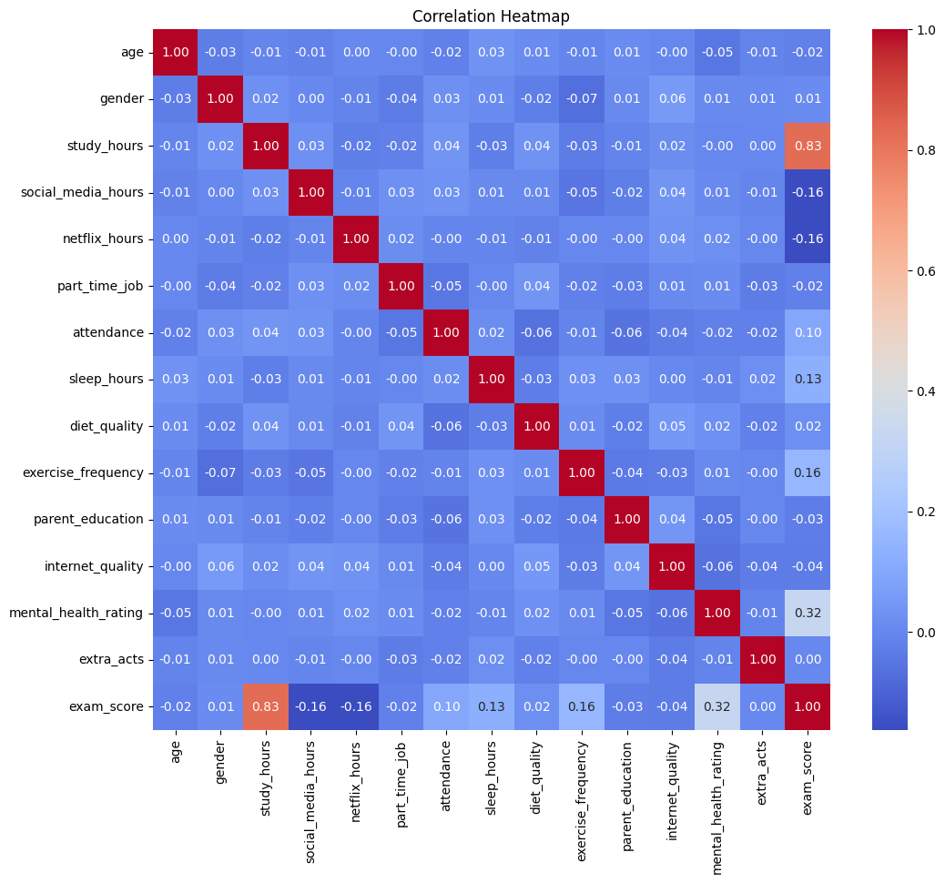
Figure 7: A correlation heatmap showing correlations between the features
This correlation heatmap quantifies the correlations between features. Orange to red colors indicate a strong positive relationship, while blue shades from normal blue to darker mean a negative relationship. The strongest positive relationship here is between exam score and study hours, with it being 0.83 which is nearly 1. Exam scores have the strongest negative relationship with social media and Netflix hours. This is because when social media and Netflix hours increase, exam scores decrease and the opposite is true as well. Most features have weak correlations between each other.

Dashboard
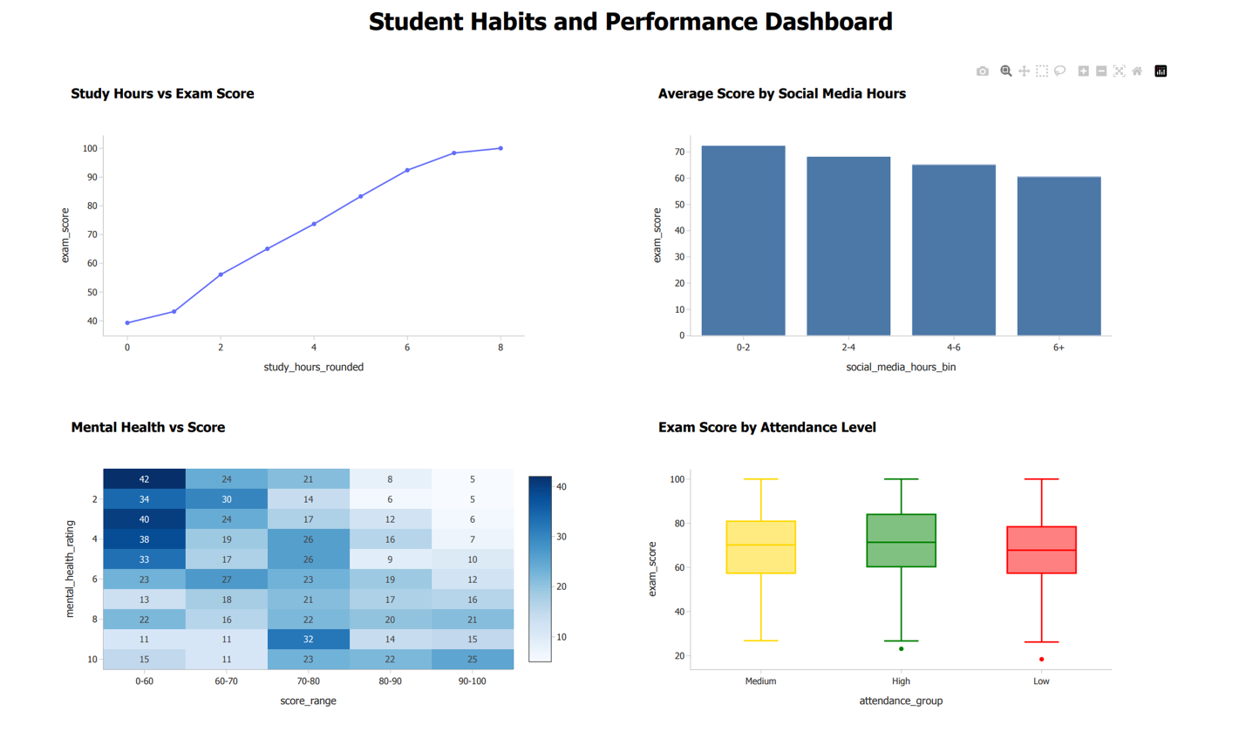
Figure 8: a dashboard combining the top charts
This dashboard combines the 4 most important charts from the study which are:
- Line chart showing the relationship between study hours and exam scores.
- Bar chart showing social media ranges and exam scores.
- Mental health score heatmap showing count of students in each mental and exam score.
- Box plots for different types of attendance.
Stakeholders who find this dashboard of interest might raise the following points:
- Study Hours vs Exam Score: Stakeholders may ask how increasing the number of hours studying before an exam will affect the outcome of taking the test, as there has been considerable evidence in data that supports that studying for more hours results in better exam scores. Stakeholders may also be able to create procedures to assist students in their study plans in the hopes of meeting the academic requirements of passing the exam based on the number of hours of studying.

- Social Media vs. Exam Score: Stakeholders may also be concerned that too much time on social media may negatively impact a student's ability to learn, and ultimately earn a grade on their tests, due to a negative correlation between time spent on social media with total exam performance. This wiring could result in suggesting limiting the amount of time spent on social media to help focus more on learning. The university can take measures such as blocking certain apps from working on campus and promoting outside-of-class activities for students to indulge in rather than waste away on social media.

- Mental Health vs Exam Score: Stakeholders could also be able to demonstrate whether students are mentally well or not based on the correlation between students who have high mental well-being and students who perform well on a test. This would lead to supporting the need for mental health services (counseling/ stress management programs) as these would likely assist students in performing academically at a high level.

- Attendance vs Exam Score: Since there is a slight relationship between attending university and receiving high exam scores, stakeholders could use their authority to insist on an attendance policy with strict enforcement therefore, encouraging students to attend their class would improve student achievement overall.

Accessibility

Accessibility was implemented to guarantee that the visualizations could be easily interpreted by all users and is the driving force behind visualization considerations. In developing visualizations, contrasting colors were used for individuals with vision impairments to be able to see the different types of charts. Box plots representing different levels of attendance were colored accordingly. Additionally, all aspects of the chart, including titles and labels, were defined clearly to avoid possible misinterpretation and provide context in a clear and minimalistic way, free from clutter and over-exaggeration. Lastly, it's important to note that only relevant and common charts were made. Therefore, there was no need for users to learn how to read a chart in a new style.
Additionally, it was important to ensure that the dashboard had appropriate usability and was convenient for supporting the decision-making process. It was necessary to give priority to select charts and order them in a suitable way. The reader would rapidly discover the information they need, then move on to other displayed information through visual techniques. Chart types that could be easily interpreted by all were used to ensure the utmost comfort and convenience, regardless of the reader.

Conclusion
In conclusion, this entire project has allowed us to experience the full process of data collection, data cleaning, and data presentation by visualization to analyze the students’ performance. The data collected and cleaned from errors and discrepancies has been made reliable enough to be used in performing any statistical and visual analysis.
The use of visualization allowed us to discover different relationships among variables, which helped us conclude that the time spent on studying was positively correlated with the test score while social media usage and movie viewing were negatively correlated; in addition, we have discovered that the students' mental health and their attendance played an essential role in students' success in university. The last dashboard is useful in presenting all our research results in an easy-to-understand visual way

References

Nath, J. (2025). Student Habits vs Academic Performance. Kaggle.com. https://www.kaggle.com/datasets/jayaantanaath/student-habits-vs-academic-performance
‌

